LAB-2

TASK-1

This Python program implements the **FizzBuzz** game using an **object-oriented approach**. The FizzBuzz class is initialized with a number n, which determines the range of the game. The play()method iterates from 1 to n, printing:

"fizz buzz" for numbers divisible by both **3 and 5**.

"fizz" for numbers divisible by **3** only.

"buzz" for numbers divisible by **5** only.

The number itself if it is **not divisible** by 3 or 5.

The game is started by creating an instance of FizzBuzz with n = 79 and calling play(), printing the output accordingly.

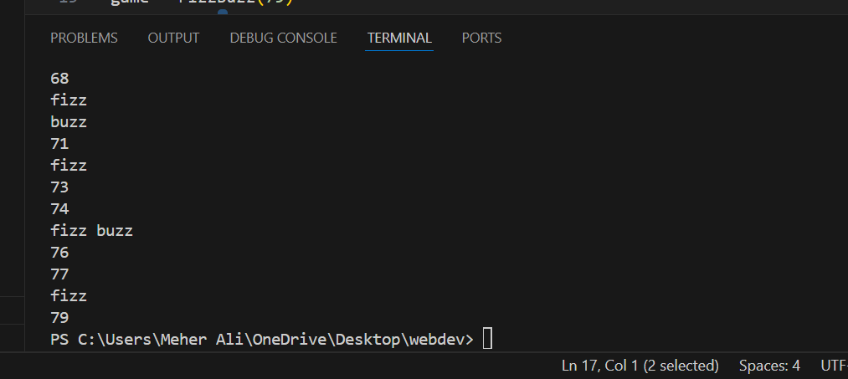

TASK-2

This Python program analyzes movie budgets using an **object-oriented approach**. The BudgetAnalyzer class takes a list of movies with their budgets and provides budget analysis. The average_budget() method calculates the **average budget** of all movies. The high_budget() method identifies movies with budgets **above the average** and calculates the difference. The show_results() method displays the **average budget**, lists **high-budget movies**, and shows the **total count**. The add_movies() method allows the user to **add more movies dynamically**. Finally, an instance of BudgetAnalyzer is created with predefined movies, allowing the user to add more and view the results.

